Kuliah minggu depan

Table MAHASISWA

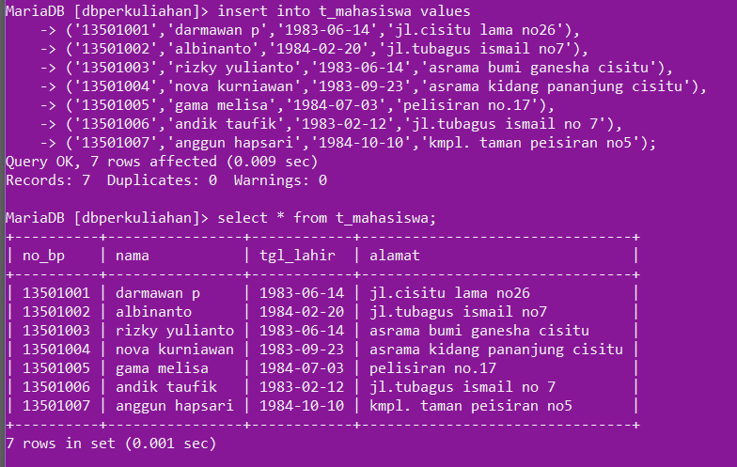

TABEL KULIAH

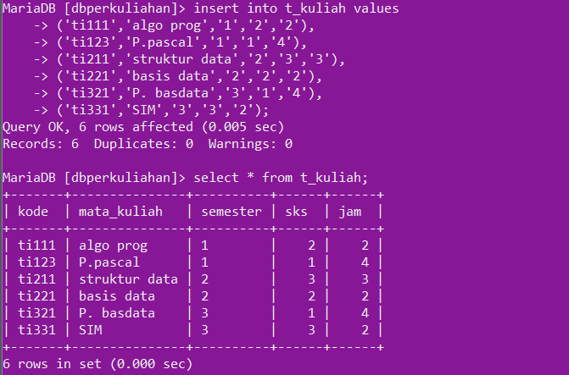

TABLE AMBIL

Insert into t_ambil values

(‘ti111’,’13501001’,’A’),

(‘ti111’,’13501002’,’B’),

(‘ti111’,’13501003’,’C’),

(‘ti111’,’13501004’,’E’),

(‘ti111’,’13501005’,’B’),

(‘ti111’,’13501006’,’D’),

(‘ti111’,’13501007’,’A’),

(‘ti123’,’13501003’,’A’),

(‘ti123’,’13501004’,’B’),

(‘ti123’,’13501005’,’B’),

(‘ti221’,’13501002’,’D’),

(‘ti221’,’13501004’,’A’),

(‘ti221’,’13501005’,’E’),

(‘ti221’,’13501007’,’B’),

(‘ti211’,’13501001’,’B’),

(‘ti211’,’13501002’,’C’),

(‘ti211’,’13501003’,’B’),

(‘ti211’,’13501004’,’B’),

(‘ti211’,’13501005’,’C’),

(‘ti211’,’13501006’,’C’),

(‘ti211’,’13501007’,’B’),

(‘ti321’,’13501001’,’C’),

(‘ti321’,’13501002’,’A’),

(‘ti321’,’13501006’,’B’),

(‘ti321’,’13501007’,’C’),

(‘ti331’,’13501001’,’C’),

(‘ti331’,’13501003’,’B’),

(‘ti331’,’13501006’,’A’);

TABEL DOSEN

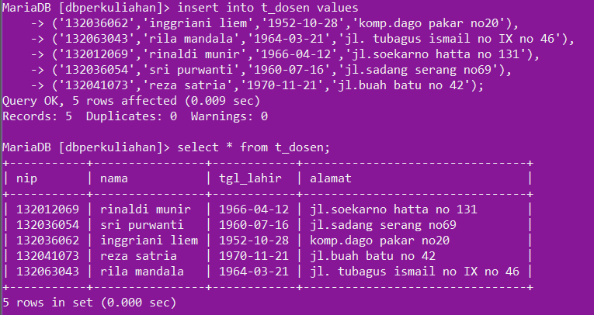

TABEL AJAR

Create table t_ajar

(kode varchar(5),

Nip varchar(12),

Waktu time,

Hari varchar(10),

Lokal varchar(5));

Insert into t_ajar values;

(‘ti111’,’132036062’,’07.00-09.00’,’senin’,’3104’),

(‘ti123’,’132003605’,’08.00-12.00’,’kamis’,’7601’),

(‘ti211’,’132036062’,’09.00-12.00’,’senin’,’3104’),

(‘ti221’,’132041073’,’09.00-11.00’,’rabu’,’3105’),

(‘ti321’,’132012069’,’13.00-17.00’,’selasa’,’7601’),

(‘ti331’,’132063043’,’07.00-09.00’,’jumat’,’3105’),